Install the Tesseract OCR

1. <https://github.com/tesseract-ocr/tesseract> Download page

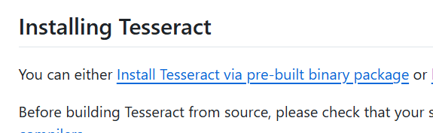



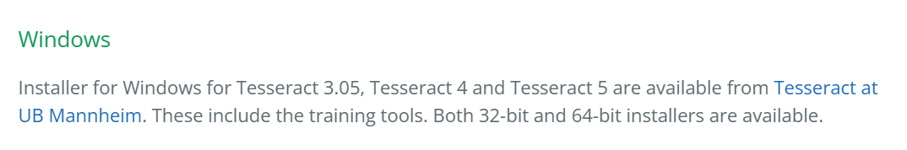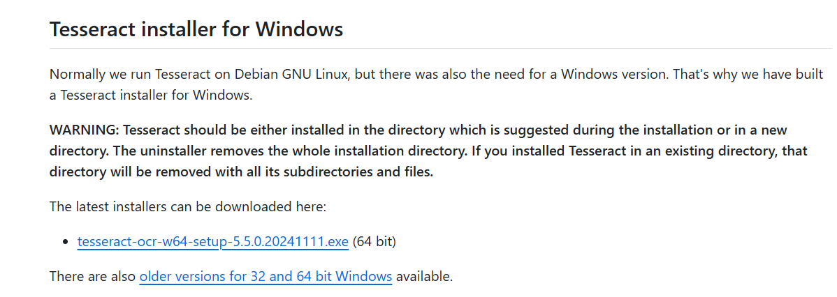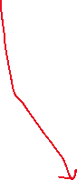

1. Install this program.
2. A screenshot of a computer

   Description automatically generated
3. A screenshot of a computer

   Description automatically generated

Next – Next -- Install

1. A screenshot of a computer

   Description automatically generated



1. We should describe its’ path. Go search bar and write “Environment Variables”

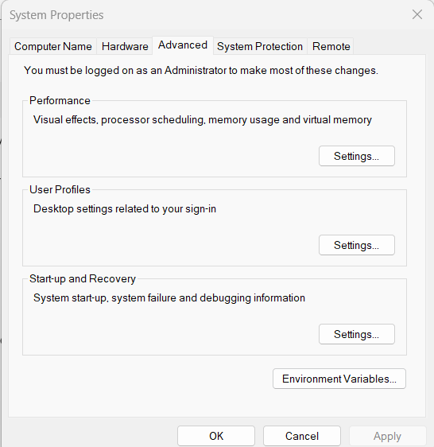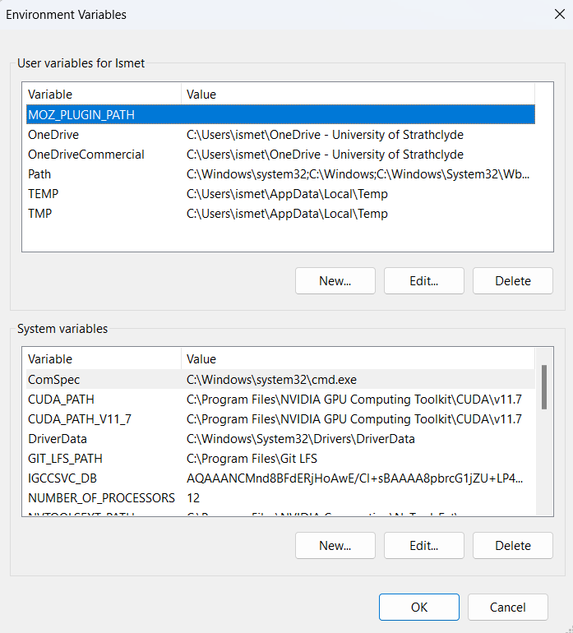

1. A screenshot of a computer program

   Description automatically generated
2. A screenshot of a computer

   Description automatically generatedWe need detect Tessaract’s path. Go to **This Computer** and find **Tesseract Folder**
3. Open it and copy its’ path like this 🡪“**C:\Program Files\Tesseract-OCR**”
4. Turn again to 🡪 “Edit environment variable” and paste your path here:



1. Turn to Notebook and enjoy….